Survey: Examples of Science Translated into Policy

SCAR Food Systems SWG Action
Contents
Introduction 1
Background 3
Questionnaire 7
1. General questions 7
2. Background details of the R&I example that translated to policy 7
3. Background details of the drivers and impacted public policy and services 9
4. The research and policy relationships of the example 10
5. Key learning’s and what happened next 13
6. Any other comments to provide: 13

Introduction
Purpose: The aim of this survey/questionnaire is to identify examples from across all member states and other participating counties of where food systems research has translated into policy.
Food systems (FS) research covers the entire value chain in its widest form and their interactions; from ecosystems services, primary production (agriculture, aquaculture & fisheries), harvesting, storage, processing, packaging, distribution, retailing, service sector, waste stream management and recycling, food and feed safety, to consumers, nutrition for citizens’ health & well-being, and diet related diseases. The term research, in this case, also covers science-based policy advice.
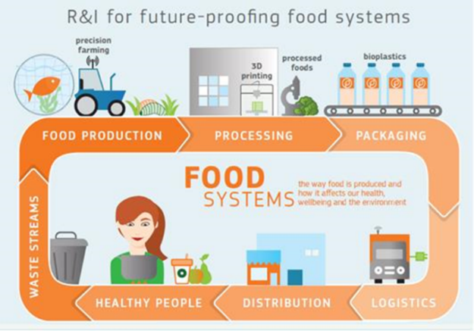
The answers from this survey are designed to be able to address four key objectives of this SCAR Food Systems SWG action:
- Explore, within member states (MS) and at European level, the links between government ministries (departments) and independent research bodies (e.g. research centres and universities) where research outcomes are considered as part of policy formation.
- Evaluate and identify examples within MS and at European level of existing policies where scientific/research outcomes that have influenced policy, focusing on the key contributing and hindering elements in the translation of science into policy.
- Identify key requirements e.g. piloting, demonstration, knowledge transfer, training, funding, and the strategic areas along the system from science to policy, where such provision of key resources would benefit uptake of research by policymakers.
- Establish a set of best practice principles that enables effective translation of science/research outputs for future policy.
To maximise the observations and learning’s from this survey, we request examples of where there has been evidence of impact on policy. We are seeking to try to avoid examples of where there currently is an intention to translate into policy. However, where the full potential impact on policy did not or has yet to fully occur, we would encourage you to include these examples and will request more information as to the hindering factors that prevented the full realisation of impact. Examples are encouraged from national and European funded projects, including innovation programmes such as EIP-Agri.
It is envisaged that representatives and/or contacts within national or European funder groups of food systems research and knowledge brokers (see definition below) may be best suited to guide the completion of this survey, as it is envisaged that input from researchers and policymakers may be required. Therefore, as much as possible the survey has been designed into sections, where questions could be completed from the perspective of the researcher, policymaker and if applicable the knowledge broker. A guide is provided at the start of each section for the role groups that could be best placed to address the questions set.
Therefore, an estimate of the time required to complete the survey cannot be provided due to the potential need for follow up interview(s) and contact with the relevant personnel.
The deadline to provide examples through the completion of the questionnaire template is 15th of September 2021. Please complete a new questionnaire for each new example.
Please return completed questionnaire(s) to livsmedel@formas.se
For questions about this survey, please contact Noeleen.mcdonald@agriculture.gov.ie

Background
What is meant by policy?
According to the Collins English dictionary policy is a set of ideas or plans that is used as a basis for making decisions, especially in politics, economics, or business. In the context of this survey we seek examples from public policy. Public Policy can be generally defined as a system of laws, regulatory measures, courses of action and funding priorities concerning a given topic promulgated by a governmental entity or its representatives.
Within this questionnaire we seek examples of national and/or European funded research and innovation (R&I) /research and development (R&D) projects that had an impact on public policy and services. Critically in these examples we seek to identify how the research findings/outcomes were effective in raising awareness to the intended policymaker and stakeholder and were subsequently incorporated into the policy cycle (Figure 1).

Figure 1: The Classic Policy Cycle
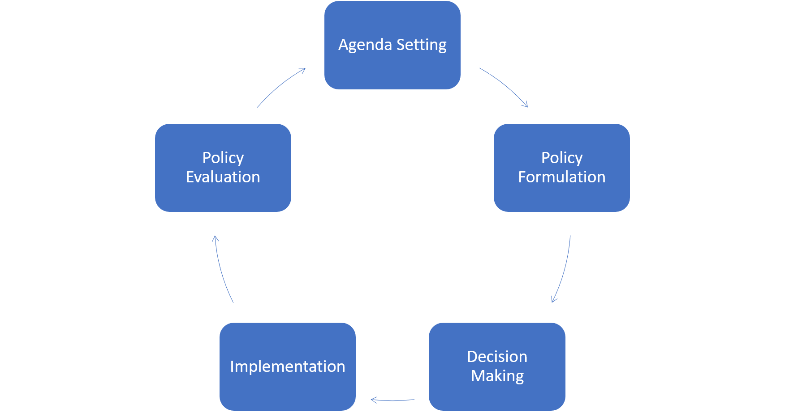

The example could be of a research project that informed the development of a new (or part of a new) policy development /scheme or service, or the revision /verification of an existing policy/scheme.
Impacts may be where the beneficiaries include government departments and their agencies, non-governmental organizations (NGOs) and other public sector organizations and society. Delivery of these impacts may occur through top-down changes to policy or public schemes, from the bottom up changes to behaviors or a combination of both. Some general examples of public policy and service impacts are as follows:
- Implementation of a new policy or revision/verification of an existing policy to improve the effectiveness, efficiency and/or responsiveness of public services or action and/or government regulation,
- Improvements in best practice that have been made based on the research project influence to public services/schemes,
- Changes to sectors within the food system that have been informed by research,
- Changes to legislation, regulations, guidelines or policies that have been informed by evidence from research

Within the policy cycle, ‘Agenda Setting’ could also be considered as a policy-driver e.g. a strategy/action/agenda for scientific research to be funded to enable new policy/scheme or the revision /verification of an existing policy/scheme to occur. Therefore, this survey also seeks to capture what policy/polices and or Strategic Research and Innovation Agenda (SRIA) acted as drivers. It may be the case that the original policy-driver for a project provided outcomes that subsequently influenced a revision/verification of the original policy-driver or updates to SRIA’s, e.g. inclusion of thematic priorities in national and/or European R&I SRIA.
To understand why the example provided may have been successful, we seek to understand the science to policy relations that operated during the research cycle and subsequent translation into policy. In addition to identifying if and what frameworks, principles and or practices were present to allow for these relations to operate in the example(s) provided.
There are four different frameworks that could be used to theorise research-policy relations that are drawn from wider social science literature. (1) Knowledge shapes policy; (2) politics shapes knowledge; (3) co-production; and (4) autonomous sphere. Figure 2 is a simplified representation of these four frameworks that are taken from and further explained in a UK research paper by Boswell & Smith (2017).

Figure 2

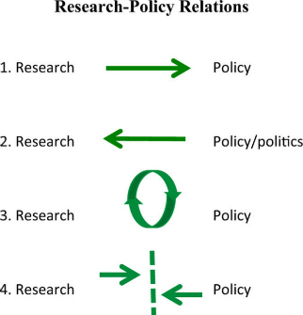

The influence of a knowledge broker as a solution to bridge the gap between science and policy relations has been increasing highlighted in many scientific fields. A knowledge broker is considered as an agent/ intermediary, who can facilitate interaction and engagement among researchers and end-users to enhance knowledge exchange, enable the use of scientific knowledge in decision-making processes and strengthen research impact.
Many people engage in knowledge brokering activities but do not hold the formal title of a ‘knowledge broker’. It is acknowledged that models of knowledge brokering vary considerably but there are a number of key discernible features of a knowledge broker:
- Makes connections between groups of people to facilitate the use of research evidence in policy making,
- Builds up relationships and networks, and are well informed,
- Keeps up to date on what is happening in their domain,
- Are trustworthy subject experts with a high level of credibility,
- Are not advocates or lobbyists for a cause.
In a recent paper by McGonigle. et al (2020) published in the journal of frontiers in sustainable food systems they state that “Knowledge brokering is considered to cover a range of activities including supplying knowledge (linking policymakers to experts), bridging (mediating and translating between science and policy), and facilitating interaction and collaboration between researchers and policymakers to co-produce knowledge. Knowledge brokers can include applied researchers, technical policy advisers (e.g., in government departments or NGOs, or the staff of third party institutions (e.g., think tanks or consultancies). In some cases, specific institutional structures either in research or policy organisations can fulfil this function.
In the broader interest of the wider impact of science to various actors and end-users, e.g. industry, this role is also be referred to as a “Innovation broker”

Questionnaire

If you are providing more than one example please complete a new questionnaire for each

General questions
Name and contact details of person providing and reporting the example

Q1.1: First Name:

Q1.2: Last Name:

Q1.3: Email:

Q1.4: Name of the organisation/institution

Q1.5: Please select the type of organisation (tick box √)
Public authority
Private sector
Research organisation/ academia
NGO
Civil society organisation
Other

Background details of the R&I example that translated to policy
Input into this section could be from the funder, researcher, and knowledge broker

Q2.1: In what Country/Countries did the research take place?

Q2.2: What category/ part of the food system does the example represent? (tick box √)
Production: Primary production
Processing: Includes food packaging

Distribution: includes logistics, trade, catering

Consumption: Includes consumer and consumer related activates
Food waste
Food safety

Q2.3: What sub-category of the food system does the example represent: (tick box √)
Production |  | Processing |  | Distribution |  | Consumption |  |  | Food waste |  | Food safety
Aquaculture |  | Feed |  | Retailing |  |  | Consumer research |  | Production |  | Production
Crops |  | Food |  | hotel-restaurant-canteen-catering |  |  | Nutrition research for health |  | Processing |  | Processing
Fishers |  | Transformation-ingredients |  | Logistics-transport-storage |  |  |  |  | Distribution |  | Distribution
Inputs |  | Packaging |  |  |  |  |  |  | Consumption |  | Consumption
Livestock

Q2.4: What was the name/title of the research project(s)

Q2.5: Briefly describe the research project(s) outlining what were the purpose/aims and objectives (the projects abstract could be provided here).

Q2.6: Names of the research institutes/university leads and partners

Q2.7: The duration of the research project (start and end dates)

Q2.8: Was the research project(s) public funded? Yes/No

If yes, please provide name of the funder and the amount (total € for the duration of the project)

Q2.9: Did the project(s) receive additional supports, i.e. private/industry funding? Yes/No

If yes, please provide name of the funder and the amount (total € for the duration of the project(s)

Q2.10: Did the project(s) have a knowledge transfer plan for dissemination of its findings? Yes/No

If yes, was this part of the funding requirement of the project(s)?

Background details of the drivers and impacted public policy and services
Input into this section could be from the funder and policymaker

Q3.1: In what Country/Countries was policy influenced by the translated research ?

Q3.2: Was there a policy-driver *for the research project? Yes/No

If yes, please provide the policy type and name of the policy

Q3.3: If yes to question 3.1, if there was a policy-driver, please provide the name of the ministries/departments/agency(s) associated.

Q3.4: If Yes to questions 3.1 & answer to 3.2, were these ministries/departments/agencies responsible for providing funding for the research project? Yes/No

If yes, please provide the amount (total € for the duration of the project)

Q3.5: What specific public policy and/or service was impacted by the scientific research? Please provide name and brief details and links to any relevant documents.
*See introduction describing policy-driver

Q3.6: How would you describe the example: (tick one box √)
- Informing/contributing to new policy/schemes
- Verification of an existing policy/scheme

Q3.7: Please select which of the following best describes the driver/ formulation of the research example (tick one box √)
 | (tick one box √) | Additional Information/Comment
Demand Led- sometimes referred to as applied or strategic research undertaken to address a specific identified problem, e.g. knowledge gap or maintenance of a policy’s relevance.
Supply led -“Blue Skies”- sometimes referred to as basic/fundamental research, that is flexible and curious-driven research that leads to outcomes not envisaged at the outset. Implementation of this type of research outcomes/findings could have lead to the development of new policy.

The research and policy relationships of the example
Background on the cooperation/relationship that enabled the change
Input into this section could be from the funder, policymaker, researcher and knowledge broker

Q4.1: Please select one of the 4 research-policy relations that best describes the framework and collaboration that existed for this example (tick one box √)
- Research Policy
Knowledge shapes policy
- Research Policy
Politics shapes knowledge
- Research Policy
Co-production
- Research Policy

Autonomous spheres

Q4.2: Were there formal structures and/or procedures in place between the research agency & /or scientist and the ministry/department/agency to aid transfer of knowledge? Yes/No

If yes, please provide details as to what these structures were e.g. principles, piloting, demonstration, operating procedures, training for the agency/scientist and/or ministry/department/agency, formal connecting activities

Q4.3: Was the transfer of knowledge between research and policy (even vice-versa) informal? E.g. personal consultation Yes/No

If yes, please provide details of what key informal connecting activities enabled the transfer.

Q4.4: Was the cooperation /relationship between the researcher and/or institute and the policymaker established before the project began? Yes/No

If yes, please provide information, such as when and how it was established and maintained

Q4.5: Was the research objective/idea a co-creation with the policymaker? Yes/No

If yes, please provide details of why and how the co-creation occurred.

Q4.6: Were there fundamental evidence dissemination activities e.g. event/publication/policy brief etc, that was the basis for which the policymaker used as part of their decision making? Yes/No

If yes, please provide the relevant details of the dissemination activity e.g. references and if online the links to access.

Q4.7: Please provide an approximate timeline of when research was carried out, was translated and informed public policy.

Q4.8: Was there a knowledge broker involved in assisting the transfer of knowledge? Yes/No.

If Yes, please provide details:

Q4.9: If yes, to question 4.8, please select the following from which the knowledge broker was associated. Under additional information, where possible please provide the name of the associated organisation and indicate if they were from the home research institute or the government ministry/agency/department or other.

 | (tick one box √) | Additional Information/Comment
Government
Ministry/agency/department
Natural resource management group

University and/or research institute

Community group

Industry representative

Other

Q4.10: Was the knowledge broker funded by the project? Yes/No

If yes, how much funding (total contribution in €). If providing estimate/approx. figure, please state this in the answer

Q4.11: What key activities did the knowledge broker use to help the translation of research to science?

Q4.12: Did the knowledge broker have established relationships and/or networks to allow transfer of knowledge? Yes/No.

If Yes, please provide details of what those relationships and/or networks were

Key learning’s and what happened next
Input into this section could be from the funder, researcher, policymaker and knowledge broker

Q5.1: Overall what were the key contributing factors that lead to this example of research influencing policy? If possible, rank in order of importance, with one being the highest order of importance.

Q5.2: Was there hindering factors in this example of research influencing policy? Yes/No

If yes, please provide details

E.g. language barriers, lack of expertise, changes in personnel, lack of resources, change in government, change in national or European priorities, etc.

If possible, rank in order of importance, with one being the highest order importance.

Q5.3: Did this example lead to other research-policy collaborations that have occurred/ on-going or planned? Yes/No

If yes, please provide details

Q5.4: Are the institutes and/or ministries part of a network to promote science activities into policy example European Science Advisory Forum?

Any other comments to provide:

Description food Systems is provided in 1st Terms of Reference of the SCAR Food Systems SWG 2016-2019 . Further definitions of the food system are provided in by the FAO, 2018 and the Scientific Group of the UN Food Systems Summit, 2020.
https://mainweb-v.musc.edu/vawprevention/policy/definition.shtml
Wellstead, A., Stedman, R. Mainstreaming and Beyond: Policy Capacity and Climate Change Decision-Making. Michigan Journal of Sustainability, Palgrave Commun 44, (2015) http://dx.doi.org/10.3998/mjs.12333712.0003.003
Research Impact Guidance pdf, accessed at https://www.gov.ie/en/publication/3d715-dafm-announces-2021-call-for-research-proposals/
Boswell, C., Smith, K. Rethinking policy ‘impact’: four models of research-policy relations. Palgrave Commun 3, 44 (2017). https://doi.org/10.1057/s41599-017-0042-z
Ward, V., House, A., & Hamer, S. (2009). Knowledge Brokering: The missing link in the evidence to action chain?. Evidence & policy : a journal of research, debate and practice, 5(3), 267–279. https://doi.org/10.1332/174426409X463811
Three ways that knowledge brokers can strengthen the impact of scientific research - Research to Action
Cummings S, Kiwanuka S, Gillman H, Regeer B. The future of knowledge brokering: perspectives from a generational framework of knowledge management for international development. Information Development. 2019;35(5):781-794. doi:10.1177/0266666918800174
McGonigle, D. et al. “A Knowledge Brokering Framework for Integrated Landscape Management.” Frontiers in Sustainable Food Systems (2020) https://doi.org/10.3389/fsufs.2020.00013
Turnhout, E., Stuiver, M., Klostermann, J., Harms, B., and Leeuwis, C. (2013). New roles of science in society: different repertoires of knowledge brokering. Sci. Public Policy 40, 354–365. doi: 10.1093/scipol/scs114
Godfrey, L., Funk, N., and Mbizvo, C. (2010). Bridging the science-policy interface: a new era for South African research and the role of knowledge brokering. S. Afr. J. Sci. 106, 1–8. doi: 10.4102/sajs.v106i5/6.247
Klerkx, L. (2012), "The role of innovation brokers in the agricultural innovation system", in Improving Agricultural Knowledge and Innovation Systems: OECD Conference Proceedings, OECD Publishing, Paris, https://doi.org/10.1787/9789264167445-19-en.

